**SPEAKING CARDS (REVISION)**

**Unit 1: Activity 2B: Role-play**

**Student A:** You are the manager of a software company. Exchange the information with your new employee about some ethical principles.

**Student B:** You are a new employee of a software company. Exchange the information with your manager about some ethical principles.

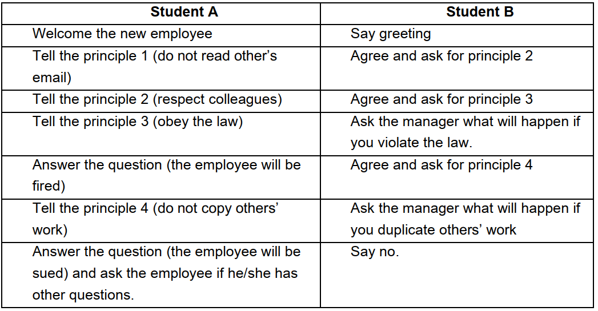

**Suggested answer:**

B: Good morning. I am Nam. I am a new employee.

A: Good morning. My name is Tuan. How can I help you?

B: Can you tell me some ethical principles of our company, please?

A: Sure./ Absolutely yes.

B: What is the first principle?

A: First, do not read other’s email.

B: Yes. What about another principle?

A: It is necessary for you to respect other colleagues. / Remember to respect other colleagues.

B: Oh, I see. How about the next principle?

A: Well, you have to obey the law. This is a very important principle.

B: Mm, if I violate the law, what will happen?

A: If you violate the law, you will be fired immediately.

B: Can you tell me about the 4th principle?

A: You are not allowed to copy others’ work.

B: What will happen if I duplicate others’ work?

A: In this case, you will be sued. Do you have other questions?

B: No. Thank you very much for your useful information!

A: You’re welcome.

**Unit 2:** **Activity 2B: Exchanging information (p.24)**

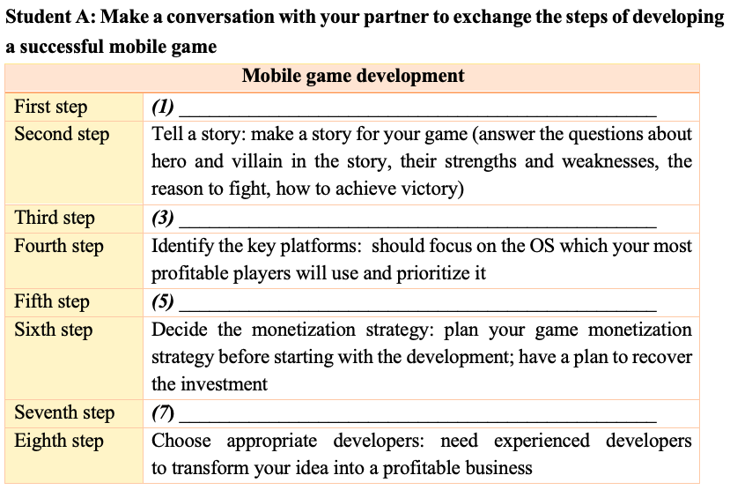

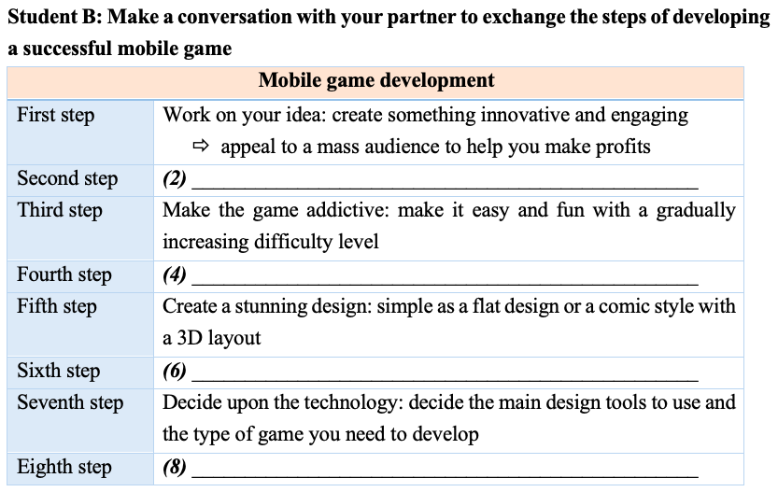

**Suggested answer:**

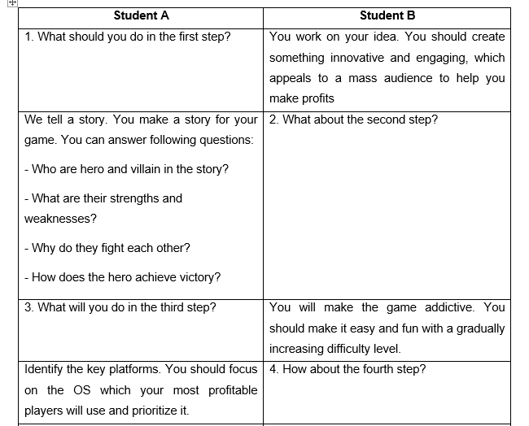

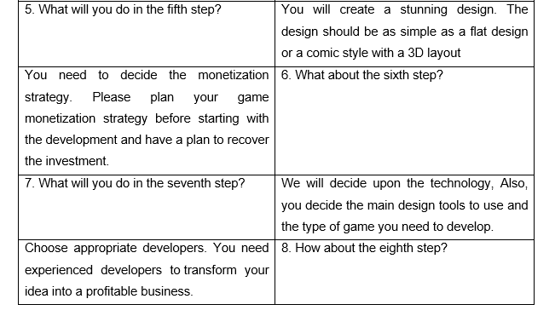

**Unit 3:** **Activity 2B: Making a conversation**

**Student A:** You are an IT expert. A trainee in your company wants you to explain to him/her about computer maintenance. Make conversation based on the given information in the card below.

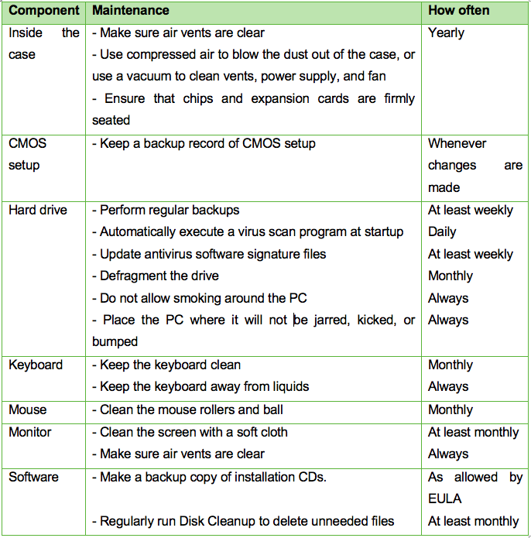

**Student B:** You are a trainee in ABC company. You want to understand about computer maintenance so you ask an IT expert to help you. Make conversation based on the given information below.

**Information needed to ask:**

* Names of components needed to maintain
* Tips to maintain the CMOS setup
* Tips to maintain the software
* Maintenance activities needed to do monthly
* Maintenance activities needed to do yearly

**Suggested answer:**

B: Good morning, sir. I’m A, a trainee in ABC company. Can you share me some tips to maintain a computer?

A: Yes, of course.

B: So what components should be maintained?

A: Well, we must maintain most of components such as hard drive, keyboard, mouse, monitor, software, components inside the case, CMOS setup… to make sure that the whole computer runs well.

B: Can you tell me what should be done to maintain the CMOS setup?

A: Remember to keep a backup record of CMOS setup whenever changes are made.

B: So what should be done to maintain the software?

A: First, you should make a backup copy of installation CDs as allowed by EULA. Second, regularly run Disk Cleanup to delete unneeded files at least once per month.

B: What maintenance activities need to be done monthly?

A: You should defragment the hard drive every month to make your computer operate smoothly. In addition, we need to keep the keyboard clean and clean the mouse rollers and ball everymonth. It’s also necessary to clean the screen with a soft cloth at least once a month.

A: What maintenance activities need to be done yearly?

B: Once a year, you need maintain components inside the computers. Make sure air vents are clear; use compressed air to blow the dust out of the case or use a vacuum to clean vents, power supply and fan; ensure that chips and expansion cards are firmly seated.

B: Well, that’s such useful information. Thank you for sharing with me.

A: You’re welcome.

**Unit 4:** **Activity 2A: Role-play (p.51, 52)**

**Student A:** a testing team leader

**Student B:** a product tester

Make a conversation to ask and give opinions and recommendation on a new IT product that is going to be launched next year based on the given information in the card.

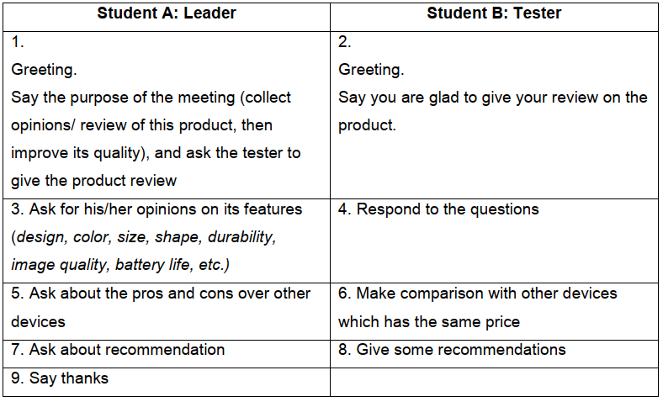

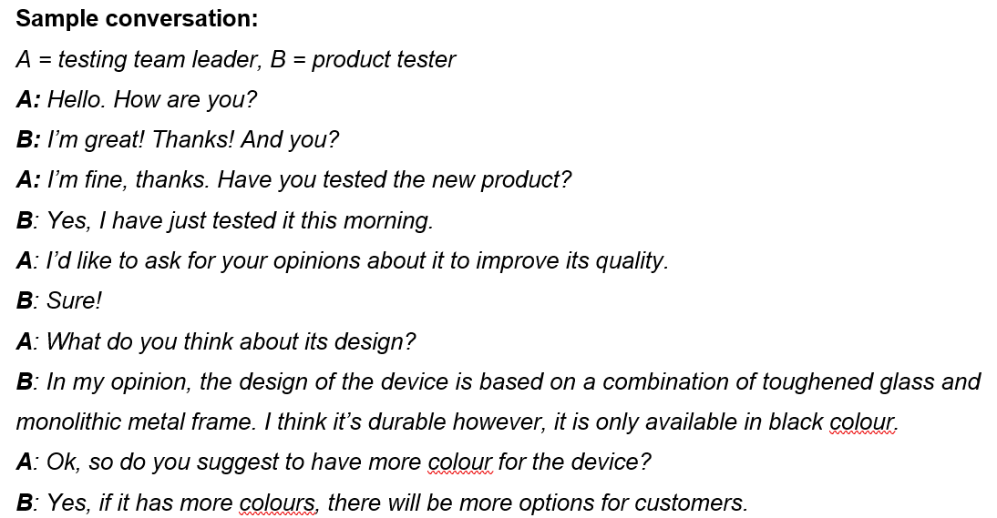

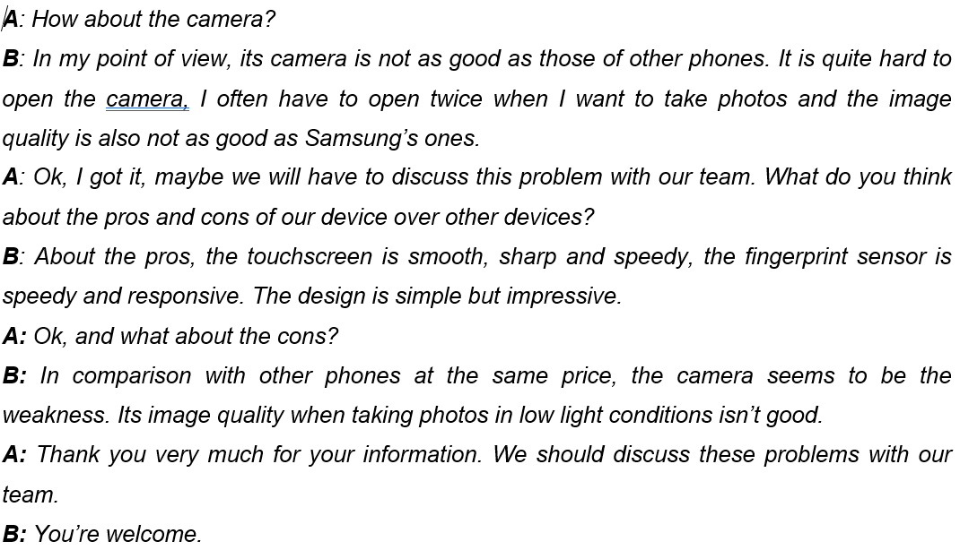

**Unit 5.1: Activity 3A: Role-play - Situation 2 (p.70)**

***A: Customer***

1. Ask to speak to tech support

2. Say you have a problem with Excel spreadsheet

3. Provide the details of the problem: The first row always shows up when printinga table that is several pages long

4. State your name and phone number

5. Confirm the details

6. Agree to the offer

7. Follow the instruction (offer verbal clues: “OK”, “I see”, or “I can do that”)

8. Confirm the resolution of the issue

***B: Technician***

1. Greet the customer and Identify yourself

2. Ask for details of the problem

3. Ask for A’s name and phone number

4. Summarize the details and ask A for confirmation

5. Apologize, then offer to give A the instruction to fix the issue

6. Provide the instruction: *click* *“Page layout” tab* ⇨ *click* *“print titles” option* ⇨ *dialogue box will open* ⇨ *select “sheet” tab (last one on the right)* ⇨ *clear “rows to repeat at top” box.*

7. Asking A to confirm if the issue has been resolved

8. Offer additional help and end the conversation

**Suggested answer:**

A: Hello, is this the customer support?

A: Yes, this is Peter, support technician. How can I help?

B: Well, I’m calling because I’m having a problem with the Excel spreadsheet.

A: Can you be more specific, please?/ What exactly is the problem?

B: Well, the first row always shows up when I print a table that is several pages long. So what should I do to remove it?

A: That’s very easy. But can I have your name and your phone number, please?

B: I’m John Walker. My phone number is 09…

A: First, let me summarize the details: your name is ..., your phone number is ... You’re having a problem with the Excel spreadsheet. The first row always shows up when I print a table that is several pages long. Is that correct?

B: That’s correct.

A: I’m sorry that has happened to you. Now I will show you how to fix this issue.

B: Great! What should I do?

A: First, you need to click on the “Page layout” tab.

B: OK, done. What’s next?

A: Right, you need to access the “print titles” option. Click on that and a dialogue box will show up. Are you following me?

B: Um, OK. I see that now.

A: Good, now click on “sheet” tab. It is the last one on the right.

B: OK I see.

A: Now delete everything in the “rows to repeat at top” box.

B: Oh, I can do that. Thanks for your help.

A: Is there anything I can help you with?

B: No, thanks again.

A: You’re welcome. Don’t hesitate to call us if you have any further questions.

**Unit 5.2: Activity 3B: Role-play - Situation 2 (p.76)**

|  |  |
| --- | --- |
| **A: Customer** | **B: Technician** |
| Ask for technical support | Greet the customer and identify yourself |
| Ask for an update on a previously reported problem (related to phone app) | Ask for ticket number |
| Ticket number: 823431 | Ask A to confirm the details  - Name: Mark Grey, address: 23, Park Hill  - Phone: Samsung 7 plus, OS: Android  - Issue: unable to make airplane ticket booking |
| - Say the details are correct  - Ask B about the progress of handling the issue | - Check connection to booking website  - Check browser version ⇨ Find no issue |
| - Express anger (you called 6 hours ago)  - Say you need to travel tomorrow | - Apologize, empathize and reassure  ⇨ Promise: on-site technician will visit in next 2 hours |
| - Say you’ll wait | - Promise: you’ll stay involved  - Offer additional help |
| Decline and end the conversation | Thank the customer and say goodbye |

**Suggested answer:**

C: Hello, is this the number of the technical support department?

T: Yes, hello, this is John, your service agent from Apex. Can I help you?

C: I’d like an update on my problem with one of your applications.

T: Can you tell me your ticket number please?

C: Let me check: 823431

T: OK, let me read back to you your details first: you are Mr. Mark Grey, address: 23 Park Hill. You are using Samsung 7 plus with Android. And you were unable to make airplane ticket booking through our booking application. Is that correct?

C: Yes that’s right. I’d like to know what you have done so far about my issue.

T: Well, we have checked your connection to the website and find no issue, your browser version is also current.

C: This is getting ridiculous. I called your company 6 hours ago. I will need to travel tomorrow. What are you going to do about this?

T: First, let me start by saying that I’m sorry this happened to you. I’m sure I’d be upset too if I were you. I’m going to do all that I can to help you. In fact, I already escalated your ticket to an on-site technician. He’s going to visit your house in the next 2 hours.

C: OK, I’ll wait

T: Please know that I’m going to personally monitor your issue and make sure that it’s taken care of. Is there anything else I can help you with?

C: No, thanks. Goodbye

T: Thank you for bringing this to our attention. Goodbye.

**Unit 6:** **Activity 6B: Exchanging information (P.92, 93)**

**Student A:** You are a job seeker. You attend a job fair and meet one of your friends, who is also looking for a job. Make a conversation with your friend (Student B) to exchange the information about your educational background, work experience, strengths and weaknesses, then look at four job requirements below, discuss and decide the most suitable option with your background.

**Student B:** You are a job seeker. You attend a job fair and meet one of your friends, who is also looking for a job. Make a conversation with your friend (student A) to exchange the information about your educational background, work experience, strengths and weaknesses, then look at four job requirements below, discuss and decide the most suitable option with your background.

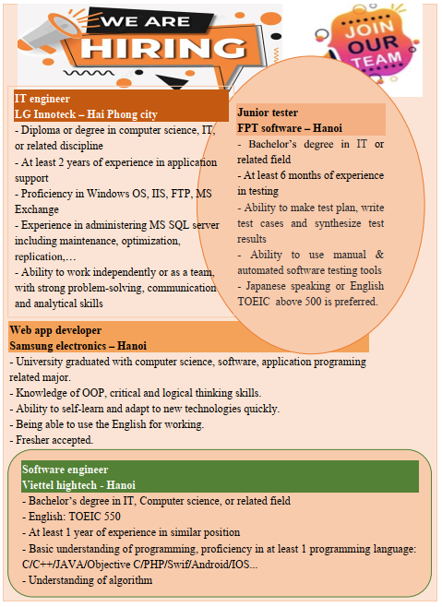

***Suggested answer:***

B: I see lots of interesting job options here. **Why don’t we discuss to find the most suitable one for you and me?**

A: **That’s great.**

B: Now, **tell me about your educational background?**

A: Well, **I graduated from Hanoi University of Industry three months ago with a bachelor’s degree in Information Technology** and a 3.8 GPA. What about you?

B: **I earned my bachelor’s degree in computer science from Hanoi University of Industry in 2022.**

A: **Have you got any work experience before?**

B: **I have worked as a part-time software engineer for F-Soft since October, 2021.** (During the time working here, I have accumulated lots of understandings and experiences in OOP, especially C++. I also have written over 10 programs in this kind of language). **So what’s your work experience?**

A: **I have 6 months of experience in testing at CMC corporation. What are your strengths and weaknesses?**

B: **I am not only skilled at using many programming languages such as COBOL, BASIC, C++, JavaScript,…, but also good at languages. I got a TOEIC certificate with a score of 650.** In addition, I’m creative and have responsibility for the work. How about you? (đọc thông tin trong card)

A: I’m really good at testing. **I have ability to make test plan, write test cases and synthesize test results. I’m also able to use manual and automated software testing tools. Additionally, I can speak Japanese and I also got a TOEIC certificate scoring of 600.** (đọc thông tin trong card)

B: **Well, I recommend you to apply for a junior tester position at FPT software** because you have more than one year of experience in testing. You can use testing tools, which are very necessary skill in this job. In addition, you can speak Japanese and English, it’ll be a bonus for you in this position.

A: **Great. And in my opinion, you might think about applying for a software engineer role in Viettel hightech** because you’re good at programming languages and had experience in this field. Your qualifications and skills really match what they require from their employees.

B: That’s for sure…

* Học phần in đậm nếu cảm thấy dài quá.

**Unit 7.1:** card trên eop

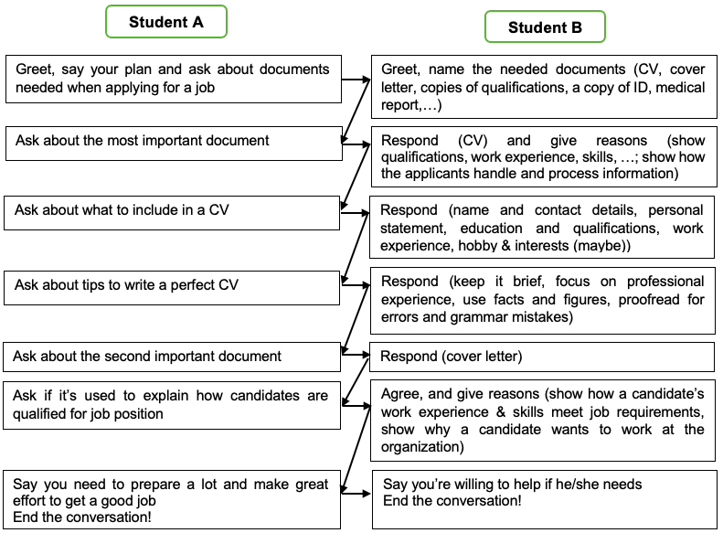

**Suggested answer:**

A: Good morning, sir. I’m a graduate student and want to look for a job now. Would you mind giving me some advice on necessary documents for my application packet?

B: Yes, certainly!

A: So what documents do I need to prepare when applying for a job?

B: Well, you need to prepare a CV, a cover letter, copies of qualifications, a copy of ID, medical report and many other ones.

A: What is the most important document in my application packet?

B: It’s CV because it shows all about candidates including qualifications, work experience, skills,…In addition, it also shows how the applicants handle and process information.

A: What information is included in a CV?

B: The details you need to include are your name and contact details, personal statement, education and qualifications, work experience, hobby & interests.

A: Can you share me some tips to write a perfect CV?

B: Well, to write a great CV, first, you need to keep it brief. Second, focus on professional experience. Third, use facts and figures. And finally, remember to proofread for errors and grammar mistakes before sending your CV to the recruiter.

A: So what is the second important document in my application packet?

B: It’s cover letter.

A: Is it used to explain how candidates are qualified for job position?

B: Exactly. A cover letter shows how a candidate’s work experience & skills meet job requirements and shows why a candidate wants to work at the organization.

B: Well, maybe I need to prepare a lot and make great effort to get a good job.

A: That’s right. I’m willing to help If you need.

A: Thank you very much for sharing time with me.

B: You’re welcome!

**Unit 7.2: Activity 3A: Information exchanging (p.105,106,107)**

**Student A:** You know a job advertised on the Internet as below. Answer student B the information about the job advertisement.

**Student B:** You are looking for a job. Ask student A the information about the job advertisement (E.g. needed job position, job responsibilities, required education, required work experience, required knowledge and skills, etc.)

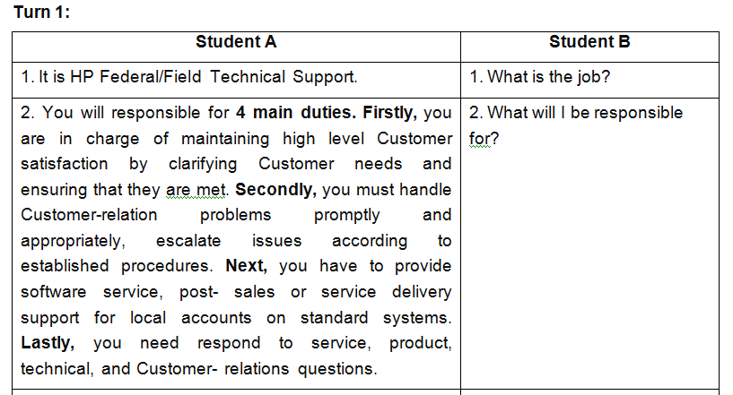

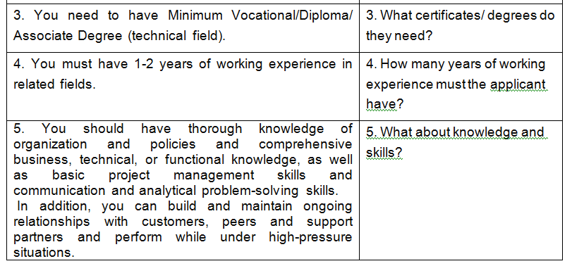

**Unit 8.1: Activity 3A: Role-play (p.124,125)**

**Student A:** You are a **head of Human Resources from HP company**. You are interviewing a candidate (student B) for the position of a network systems administrator. Make a job interview with your partner based on given information in the card.

**Student B:** You are **an interviewee for the position of a** **network systems administrator in HP company**. Use the given information in the card to respond to the interviewer (student A)’s questions.

|  |  |
| --- | --- |
| **A = Interviewer** | **B = Interviewee** |
| 1. Greet, identify yourself and welcome the candidate  Ask the candidate to introduce himself/herself | 2. Respond to the interviewer’s greeting  Introduce yourself: name, educational background and personalities |
| 3. Ask how she/he heard about the position | 4. Respond |
| 5. Ask why he/she wants to work for your company | 6. Respond |
| 7. Ask about his/ her working experience | 8. Respond |
| 9. Ask about his/her job duties at the previous company | 10. Respond |
| 11. Ask why she/he wants to leave the current job | 12. Give reasons |
| 13. Ask about his/ her future plans in the next three years | 14. Respond |
| 15. Ask whether she/ he has any questions | 16. Say “yes” and ask about the short-term goal of the company |
| 17. Respond | 18. Say that you wish to be a part of his/ her company |
| 19. Say the time to inform the result of the interview  End the interview | 20. Say thanks and goodbye |

**Suggested answer:**

A: Good morning. I am …, Head of Human Resources of ABC company. I’ll be interviewing you today. Why don’t you start by introducing a little bit about yourself?

B: Sure. Nice to meet you. My name is …. I’m... years old. Now, I’m living in ... I graduated from Hanoi University of Industry with a bachelor’s degree in Information Technology. I would describe myself as someone who is organized and creative.

A: That sounds good. How did you hear about this position?

B: Actually, I read about it on a website.

A: Why do you want to work for our company?

B: Firstly, I think that I have right skills and experience for this position. Secondly, your company offers attractive salary and overseas training opportunities So this is a good chance for me to grow my career.

A: Can you tell me about your working experience, please?

B: From 2020 and 2023, I have been working as a network supervisor at CMC Technology and Solutions company.

A: What are your duties at CMC?

B: I am mainly in charge of implementing, managing and troubleshooting CMC’s network. Sometimes, I have to install, maintain and upgrade software or hardware.

A: Why do you want to leave that job?

B: I expect higher income to take better care of my family. Also, I'm looking for a company that I can settle down and make a long-term contribution.

A: What are your future plans in the next three years?

B: Well, I’d love *to be* become a senior network systems administrator in your company.

*A: That’s good to hear. Do you have any questions for me?*

*B: Yes, I do. Could you tell me about* the short-term goal of your company?

A: Good question. We are going to open another branch in HCM next month.

B: That sounds interesting. I wish to be a part of your company.

A: We will get back to with the result within 2 weeks.Thanks for coming. Bye.

B: Thank you for your time. Goodbye.

**Unit 8.2: p.84- teacher’s handout**

**Student A:** You are a **head of Human Resources from Samsung company**. You are interviewing a candidate (student B) for the position of a software developer. Make a job interview with your partner based on given information in the card.

**Student B:** You are **an interviewee for the position of a software developer in Samsung company**. Use the given information in the card to respond to the interviewer (student A)’s questions.

|  |  |
| --- | --- |
| **A = interviewer** | **B = interviewee** |
| 1. Greet, introduce your name and position | 2. Respond to the interviewer’s greeting |
| 3. Ask the candidate to introduce himself/herself | 4. Introduce yourself |
| 5. Ask about his/her strength and weakness | 6. Respond |
| 7. Ask how he/she heard about the position | 8. Respond |
| 9. Ask about his/her working experience | 10. Respond |
| 11. Ask about his/her job responsibilities in last company | 12. Respond |
| 13. Ask why she/he wants to leave that job | 14. Give reasons |
| 15. Ask about his/her salary expectation for this new position | 16. Respond |
| 17. Ask about his/her future plan in two coming years | 18. Respond |
| 19. Ask if he/she has any questions | 20. Answer and ask about the short-term and long-term goal of the company |
| 21. Respond | 22. Ask when you get the result of the interview |
| 23. Respond | 24. Say thanks and goodbye |

**Suggested answer:**

A: Good morning. I am (A), the Human Resources manager of ABC company. I’ll be interviewing you today. Can you introduce a little bit about yourself?

B: Sure. Nice to meet you. My name is (B).... I’m... years old. Now, I’m living in ... I graduated from Hanoi University of  Industry with a bachelor’s degree in Information Technology. I would describe myself as someone who is organized and creative.

A: What are your greatest strengths and weaknesses?

B: Well, I am skilled at working under high pressure and mastering high-level programming languages. But I’m afraid of speaking in front of public.

A: OK. How did you heard about this position?

B: Actually, I read about it on a website.

A: Can you tell me about your working experience, please?

B: I took a part-time job as a programmer when I was the fourth-year student at HaUI. Besides, I have been working as a software developer in ... company since I graduated from university.

A: What are your responsibilities in the last company?

B: I’m in responsible for designing, coding, testing, and debugging software applications.

A: Why do you want to leave that job?

B: I expect higher income to take better care of my family. Also, I'm looking for a company that I can settle down and make a long-term contribution.

A: What’s your salary expectation?

B: I hope that my salary is in line with my qualifications. I expect to be paid about 1,000 USD.

A: What’s your future plan in two coming years?

B: Well, I’d love to be a senior software developer.

A: That’s good to hear. Do you have any questions for me?

B: Yes, I do. Could you tell me about the short-term and long-term goal of your company?

A: Good question. We are going to launch a new software application next month and our long term goal is to open another branch in Singapore.

B: So, when will I get the result of the interview?

A: Within 2 weeks.

B: Ok. Thank you for your time. Goodbye.

A: Thanks for coming. Bye.